--D.1

SELECT

vbm_egy.date as 'Observation Date'

, li_egy.Location as 'Country 1 Name'

, sum(vbm_egy.total_vaccinations) as 'Administered Vaccine in Country 1'

, li_chn.Location as 'Country 1 Name'

, sum(vbm_chn.total_vaccinations) as 'Administered Vaccine in Country 1'

, sum(vbm_egy.total_vaccinations) - sum(vbm_chn.total_vaccinations) as 'Difference of totals'

FROM

vaccinations_by_manufacturer vbm_egy

JOIN

Location_info li_egy

ON

li_egy.iso_code = vbm_egy.iso_code

JOIN

vaccinations_by_manufacturer vbm_chn

ON

vbm_egy.date = vbm_chn.date

JOIN

Location_info li_chn

ON

li_chn.iso_code = vbm_chn.iso_code

WHERE

vbm_egy.iso_code = 'EGY'

AND

vbm_chn.iso_code = 'CHN'

GROUP BY

vbm_egy.date ;

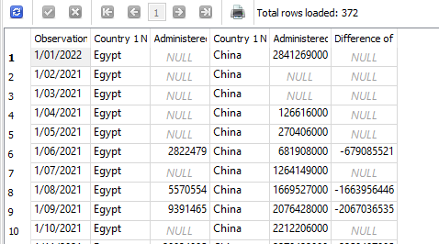

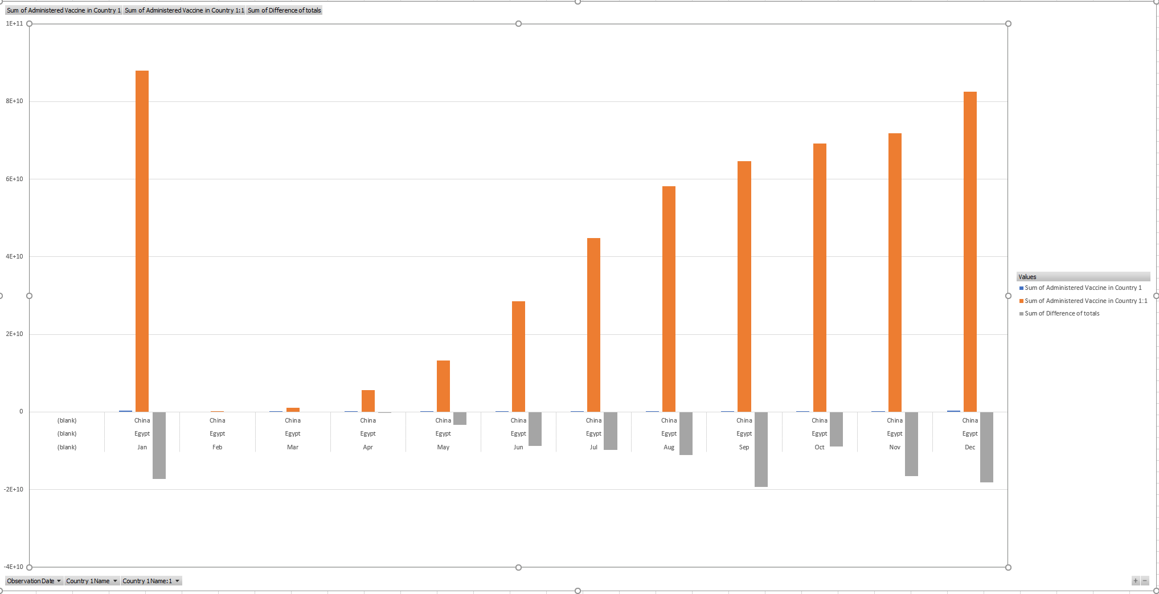

--D.2

SELECT

li.location as Country

, sum(daily_vaccinations) as 'Cumulative Doses'

FROM

Vaccination_By_Location vbl

JOIN

Location_info li

ON

vbl.iso_code = li.iso_code

GROUP BY

li.location ;

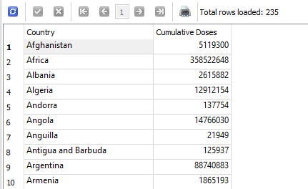

-- D.3

SELECT

DISTINCT

li.location as Country

, vaccine as 'Vaccine Type'

FROM

vaccinations_by_manufacturer vbm

JOIN

Location_info li

ON

vbm.iso_code = li.iso_code

AND

vbm.vaccine != 'Unknown';

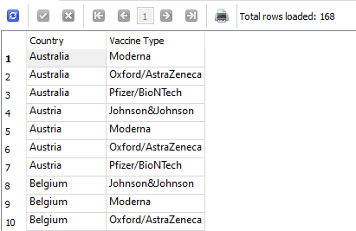

-- D.4

SELECT

li.source_name

, sum(vbm.total_vaccinations)

, li.source_url

FROM

vaccinations_by_manufacturer vbm

JOIN

Location_info li

ON

vbm.iso_code = li.iso_code

where source_name is not null

GROUP BY

li.source_name

ORDER BY

li.source_name

, li.source_url;

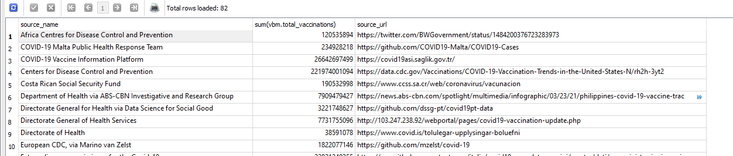

--D.5

SELECT

aus.date

, aus.people_fully_vaccinated as Australia

, can.people_fully_vaccinated as Canada

, grb.people_fully_vaccinated as England

, pol.people_fully_vaccinated as Poland

FROM

Vaccination_By_Location aus

JOIN

Vaccination_By_Location can

ON

aus.date = can.date

AND

can.iso_code = 'CAN'

JOIN

Vaccination_By_Location grb

ON

aus.date = grb.date

AND

grb.iso_code = 'OWID_ENG'

JOIN

Vaccination_By_Location pol

ON

aus.date = pol.date

AND

pol.iso_code = 'POL'

WHERE

aus.iso_code = 'AUS'

